

Lecture 1:

Introduction



Fei-Fei Li & Andrej Karpathy & Justin Johnson

|  |  |
| --- | --- |
| Lecture 1 - 1 | 4-Jan-16 |

Welcome to CS231n



Fei-Fei Li & Andrej Karpathy & Justin Johnson

|  |  |
| --- | --- |
| Lecture 1 - 2 | 4-Jan-16 |

**Biology**

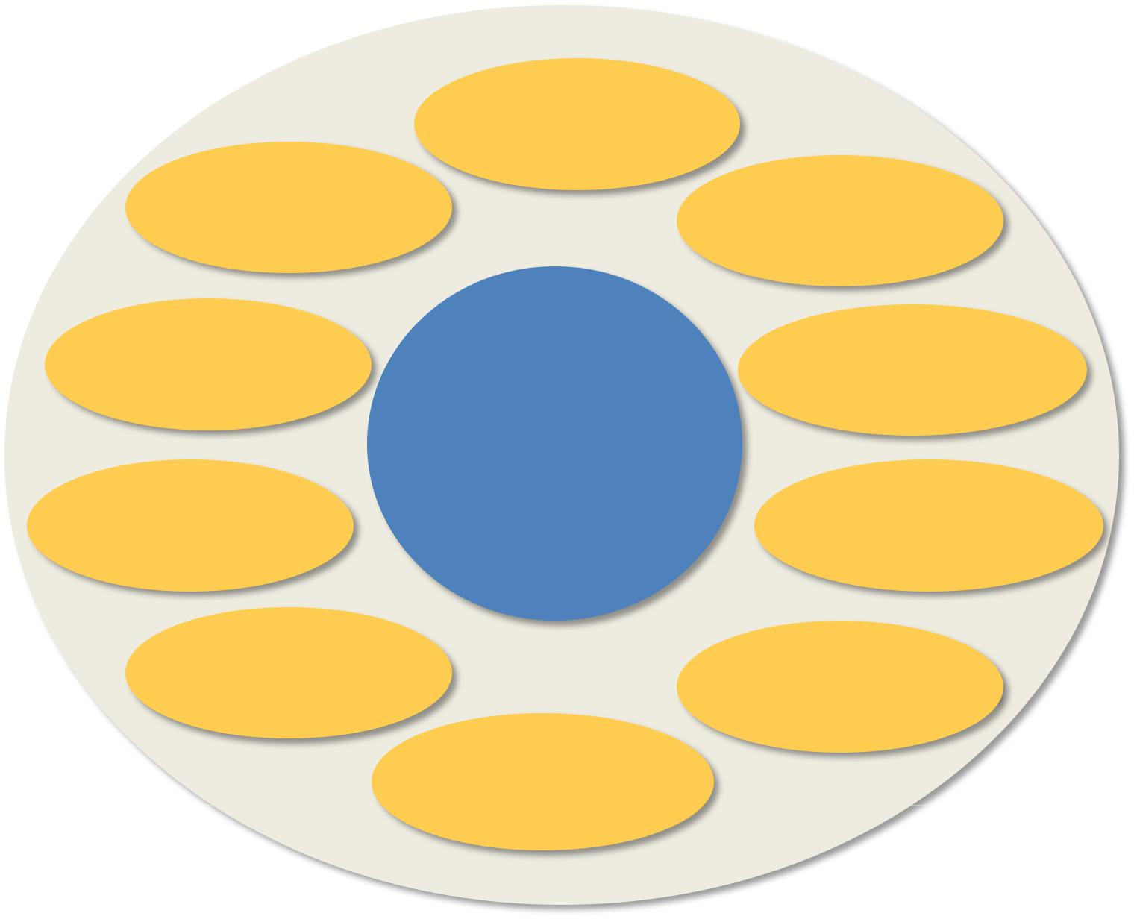

**Psychology**

|  |  |  |  |  |
| --- | --- | --- | --- | --- |
|  |  | Neuroscience |  |  |
| **Physics** | optics |  | Cognitive |  |
|  |  |  | sciences |  |
|  | Image |  | graphics, algorithms, |  |
| processing | | **Computer** | theory,**…** |  |
|  |  |  |  |
| Speech, NLP | | **Vision** | systems, |  |
|  | architecture, **…** |  |
|  |  |  |  |

**Computer Science**

|  |  |  |  |
| --- | --- | --- | --- |
| **Engineering** | Robotics | Information retrieval |  |
|  |  |
|  |  |  |

Machine learning

**Mathematics**



Fei-Fei Li & Andrej Karpathy & Justin Johnson

|  |  |
| --- | --- |
| Lecture 1 - 3 | 4-Jan-16 |

**Biology**

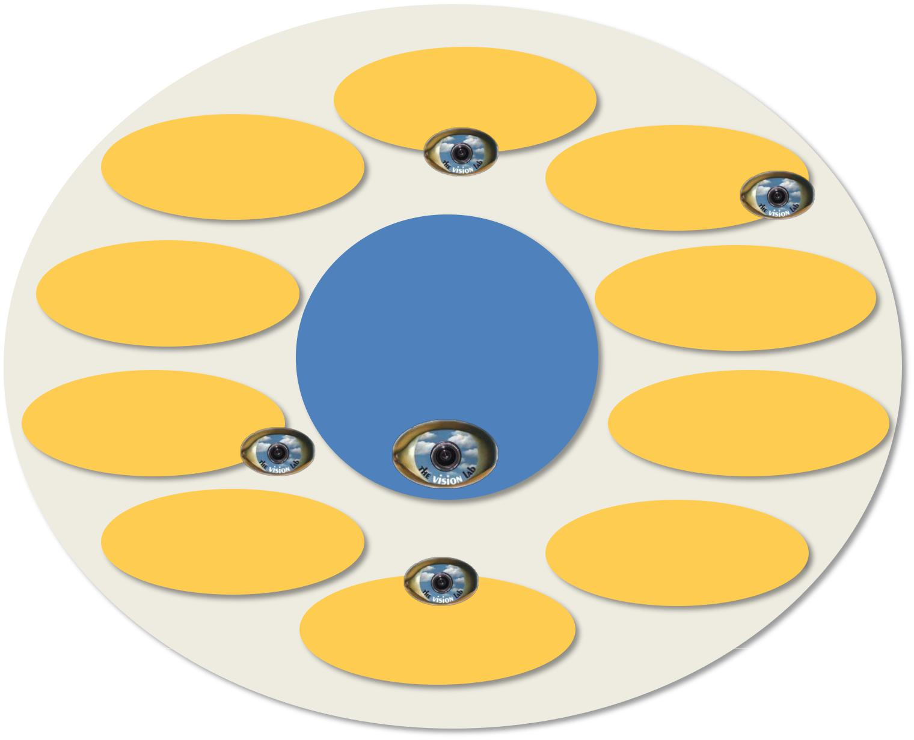

**Psychology**

|  |  |  |  |  |
| --- | --- | --- | --- | --- |
|  |  | Neuroscience |  |  |
| **Physics** | optics |  | Cognitive |  |
|  |  |  | sciences |  |
|  | Image |  | graphics, algorithms, |  |
| processing | | **Computer** | theory,**…** |  |
|  |  |  |  |
| Speech, NLP | | **Vision** | systems, |  |
|  | architecture, **…** |  |
|  |  |  |  |

**Computer Science**

|  |  |  |  |
| --- | --- | --- | --- |
| **Engineering** | Robotics | Information retrieval |  |
|  |  |
|  |  |  |

Machine learning

**Mathematics**



Fei-Fei Li & Andrej Karpathy & Justin Johnson

|  |  |
| --- | --- |
| Lecture 1 - 4 | 4-Jan-16 |

Computer Vision courses @ Stanford

* CS131 (fall, 2015, Profs. Fei-Fei Li & Juan Carlos Niebles):

**–** Undergraduate introductory class

* CS231a (spring term, Prof. Silvio Savarese)

**–** Core computer vision class for seniors, masters, andPhDs

**–** Topics include image processing, cameras, 3Dreconstruction, segmentation, object recognition, scene understanding

* **CS231n (this term, Prof. Fei-Fei Li & Andrej Karpathy & Justin Johnson)**

**– Neural network (aka “deep learning”) class on image classification**

* And an assortment of CS331 and CS431 for advanced topics in computer vision



Fei-Fei Li & Andrej Karpathy & Justin Johnson

|  |  |
| --- | --- |
| Lecture 1 - 5 | 4-Jan-16 |

Today**’**s agenda

* A brief history of computer vision
* CS231n overview



Fei-Fei Li & Andrej Karpathy & Justin Johnson

|  |  |
| --- | --- |
| Lecture 1 - 6 | 4-Jan-16 |



543million years, B.C.

Fei-Fei Li & Andrej Karpathy & Justin Johnson

|  |  |
| --- | --- |
| Lecture 1 - 7 | 4-Jan-16 |

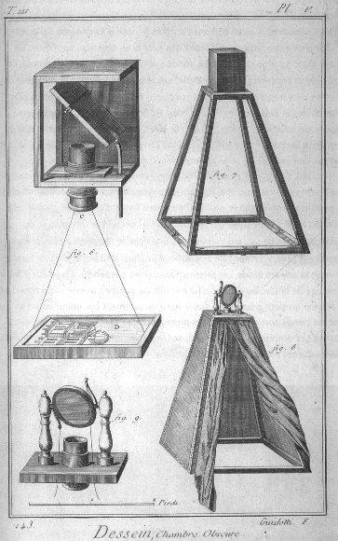

Camera Obscura

Leonardo da Vinci 16th Century, A.D.



Fei-Fei Li & Andrej Karpathy & Justin Johnson

|  |  |
| --- | --- |
| Lecture 1 - 8 | 4-Jan-16 |

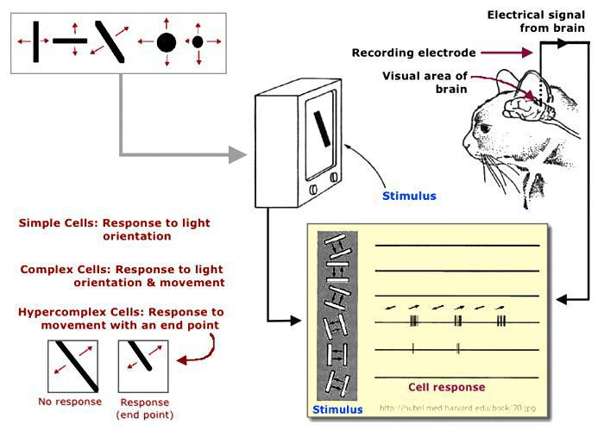

Hubel & Wiesel, 1959



Fei-Fei Li & Andrej Karpathy & Justin Johnson

|  |  |
| --- | --- |
| Lecture 1 - 9 | 4-Jan-16 |

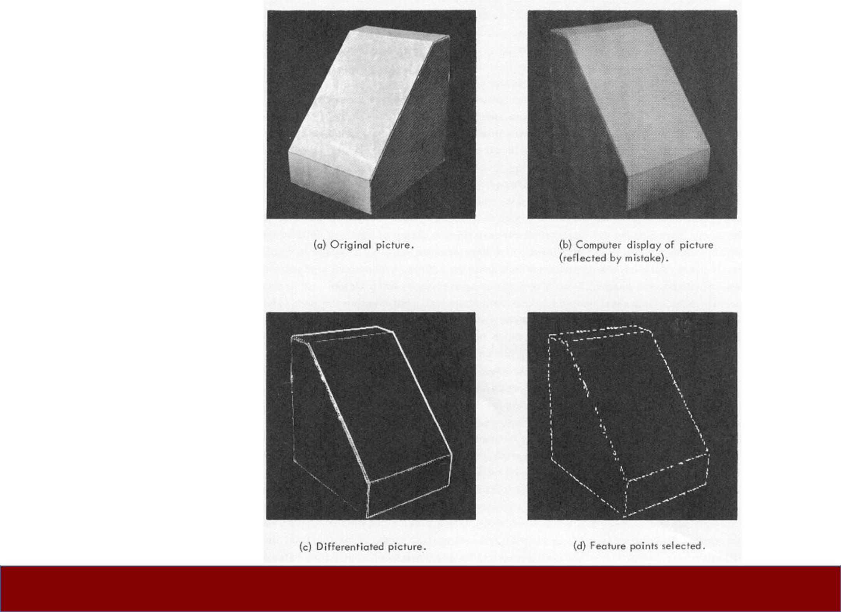

Block

world

Larry Roberts, 1963

Fei-Fei Li & Andrej Karpathy & Justin Johnson

|  |  |
| --- | --- |
| Lecture 1 - 10 | 4-Jan-16 |

Fei-Fei Li & Andrej Karpathy & Justin Johnson

|  |  |
| --- | --- |
| Lecture 1 - 11 | 4-Jan-16 |

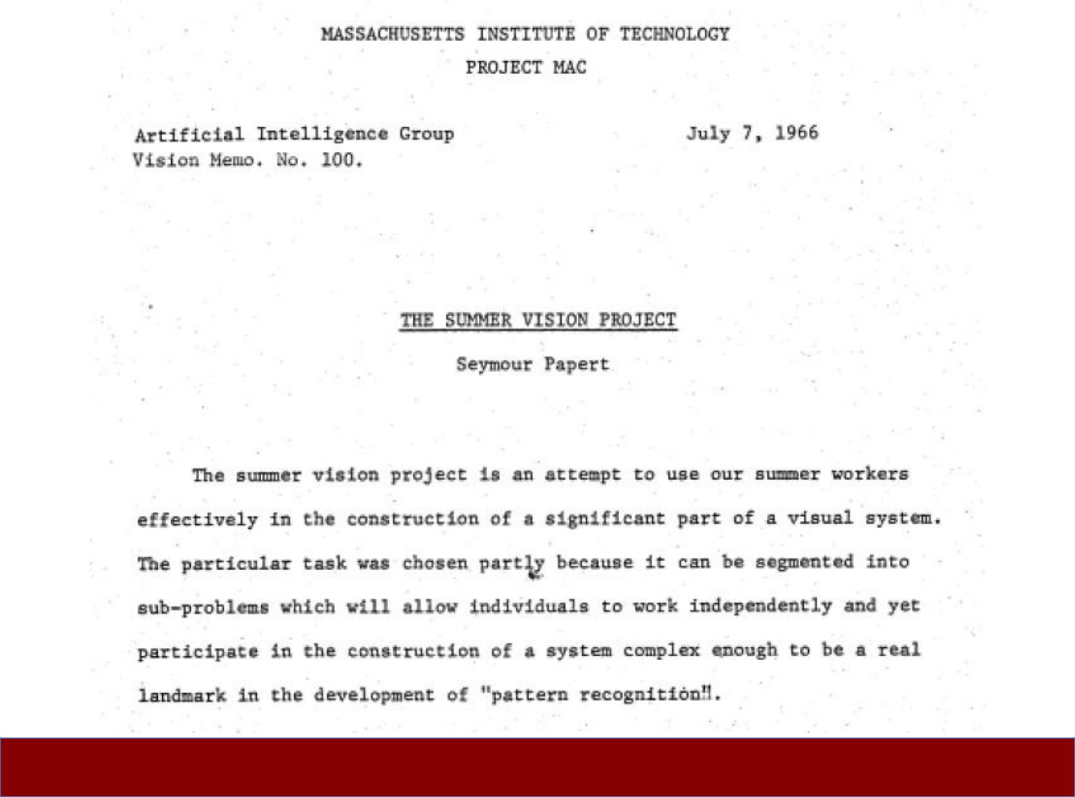



David Marr, 1970s



Fei-Fei Li & Andrej Karpathy & Justin Johnson

|  |  |
| --- | --- |
| Lecture 1 - 12 | 4-Jan-16 |

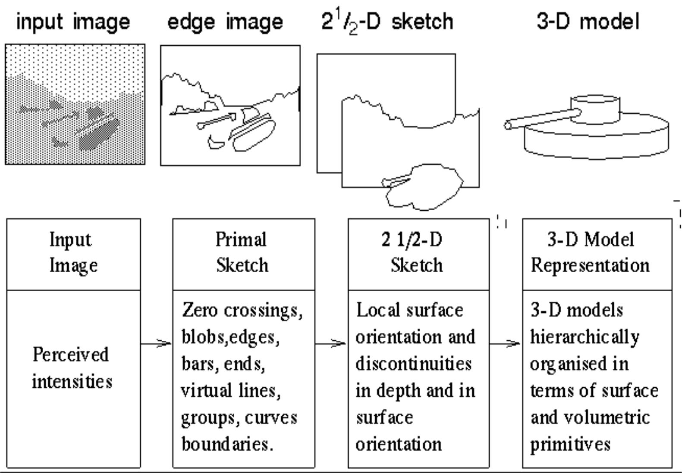

Stages of Visual Representation, David Marr, 1970s



Fei-Fei Li & Andrej Karpathy & Justin Johnson

|  |  |
| --- | --- |
| Lecture 1 - 13 | 4-Jan-16 |

**•** Generalized Cylinder **•** Pictorial Structure

Brooks & Binford, 1979 Fischler and Elschlager, 1973

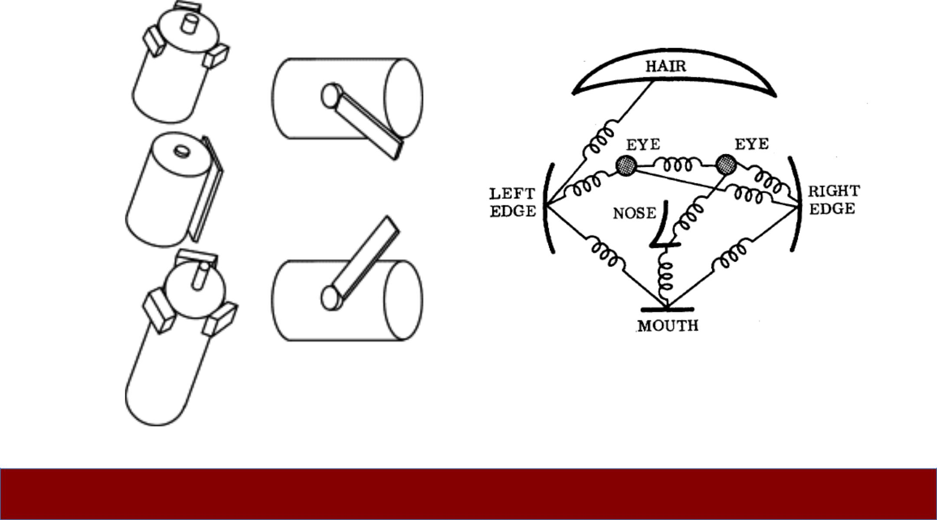

Fei-Fei Li & Andrej Karpathy & Justin Johnson

|  |  |
| --- | --- |
| Lecture 1 - 14 | 4-Jan-16 |

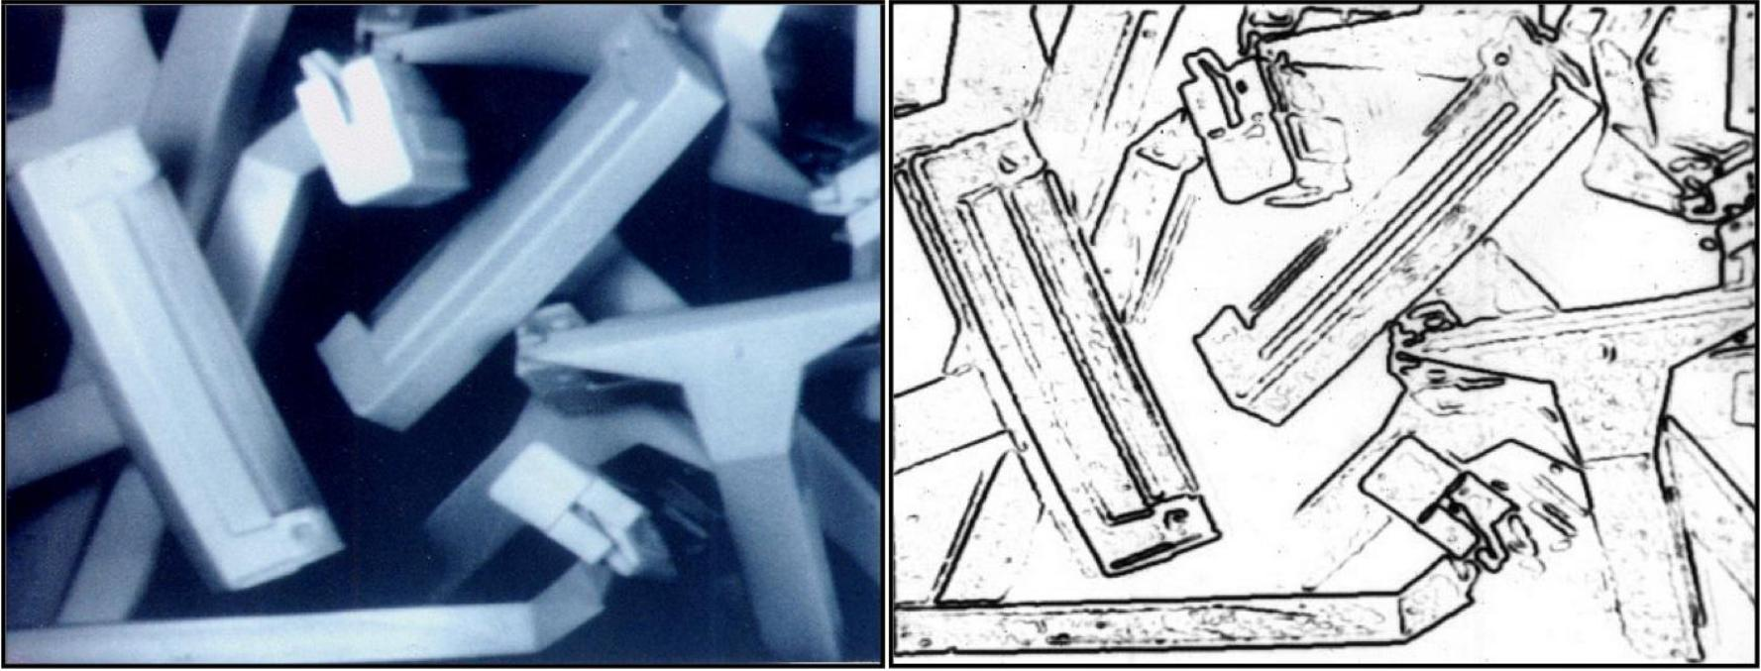

David Lowe, 1987



Fei-Fei Li & Andrej Karpathy & Justin Johnson

|  |  |
| --- | --- |
| Lecture 1 - 15 | 4-Jan-16 |

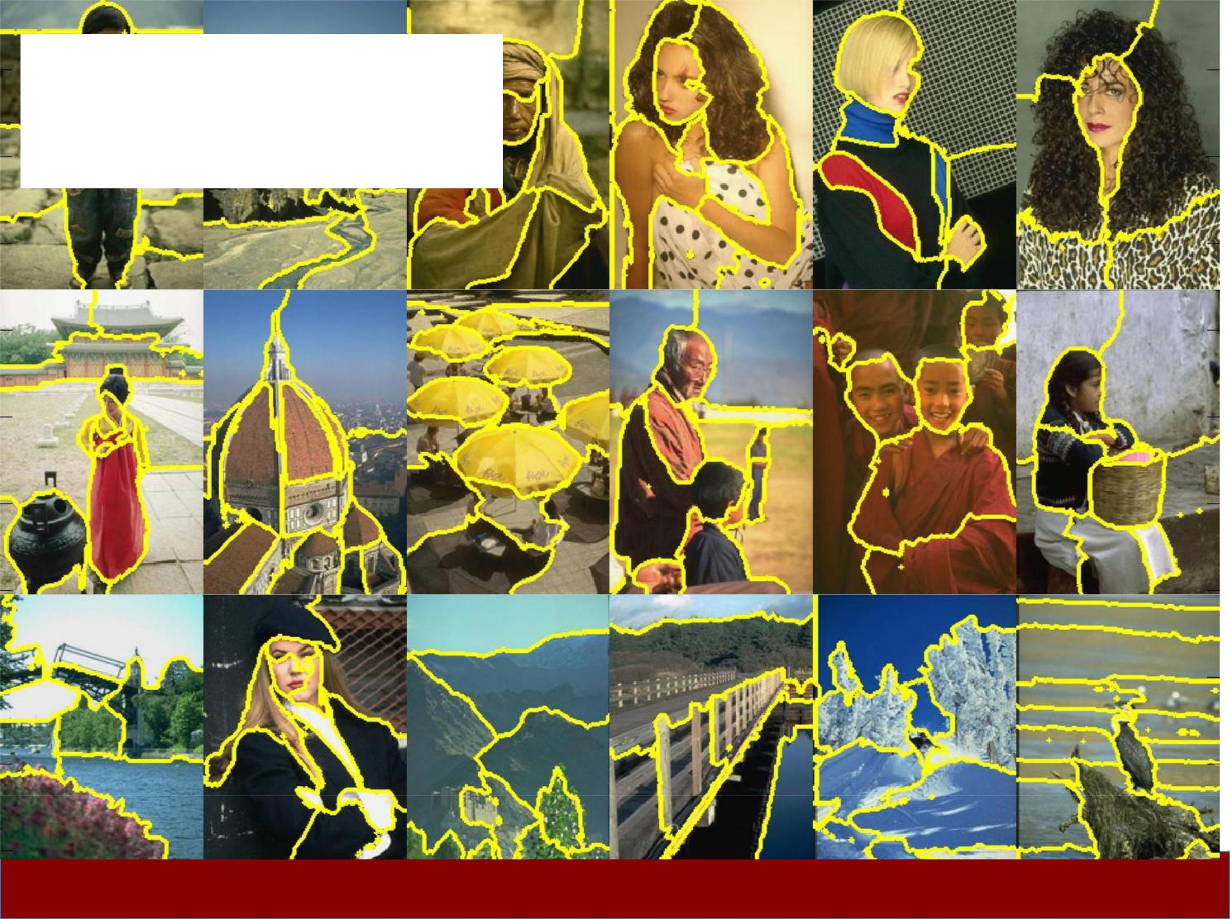

Normalized Cut

(Shi & Malik, 1997)

Fei-Fei Li & Andrej Karpathy & Justin Johnson

|  |  |
| --- | --- |
| Lecture 1 - 16 | 4-Jan-16 |

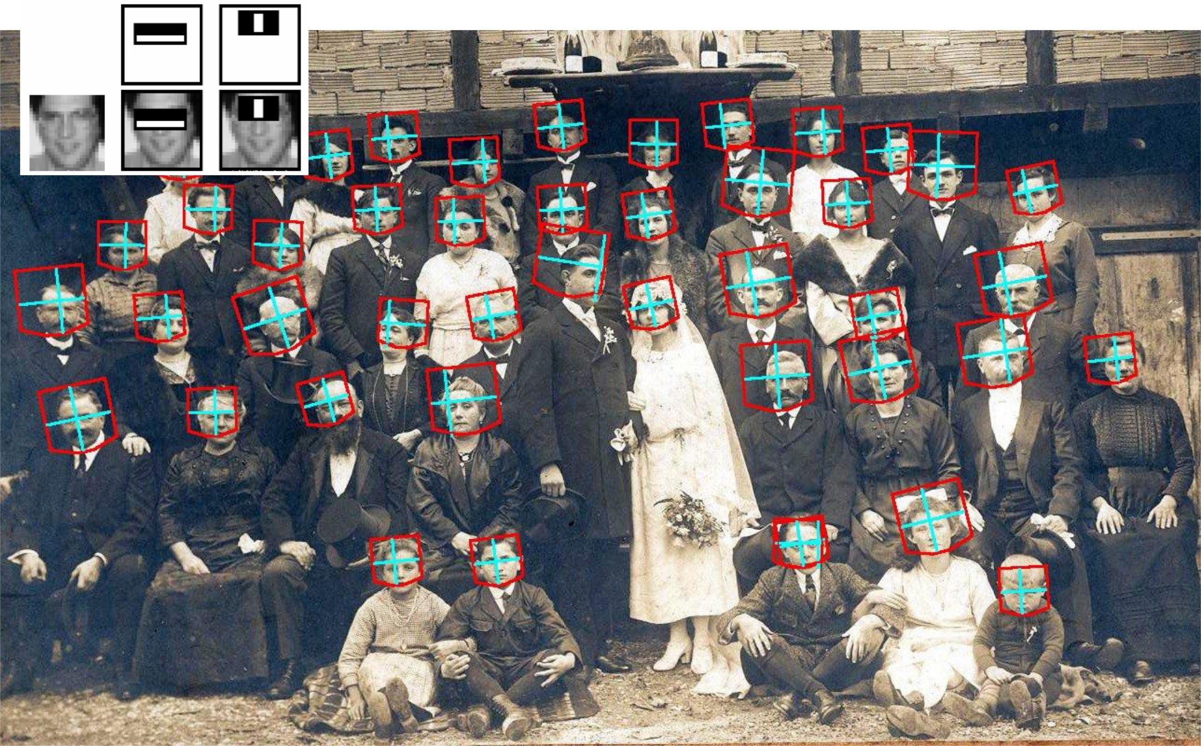

Face Detection, Viola & Jones, 2001



Fei-Fei Li & Andrej Karpathy & Justin Johnson

|  |  |
| --- | --- |
| Lecture 1 - 17 | 4-Jan-16 |

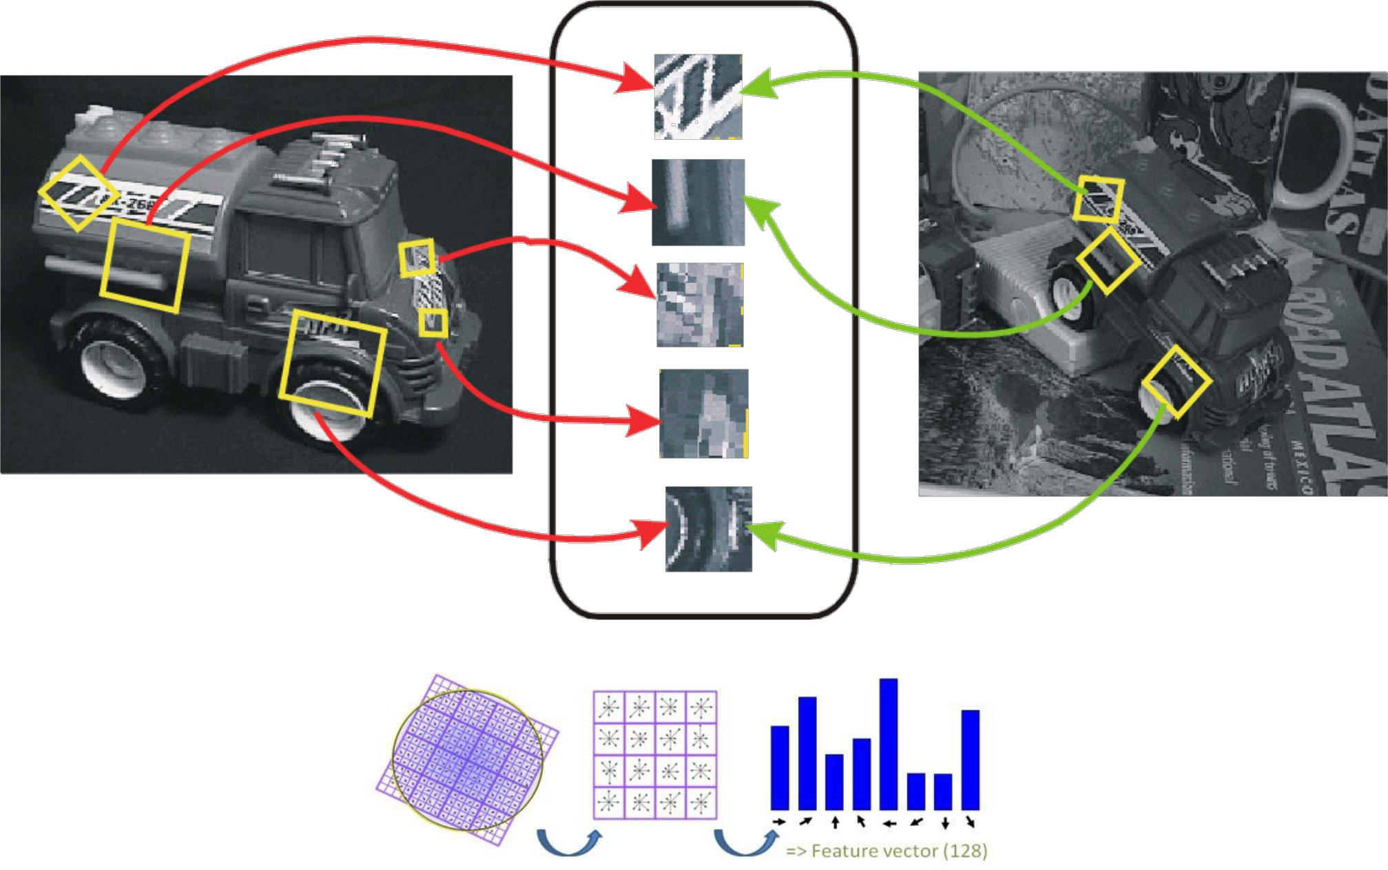

**“**SIFT**”** & Object Recognition, David Lowe, 1999



Fei-Fei Li & Andrej Karpathy & Justin Johnson

|  |  |
| --- | --- |
| Lecture 1 - 18 | 4-Jan-16 |

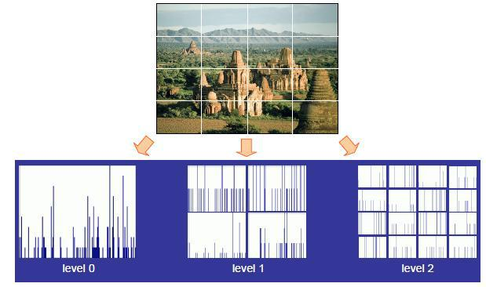

Spatial Pyramid Matching, Lazebnik, Schmid & Ponce, 2006



Fei-Fei Li & Andrej Karpathy & Justin Johnson

|  |  |
| --- | --- |
| Lecture 1 - 19 | 4-Jan-16 |

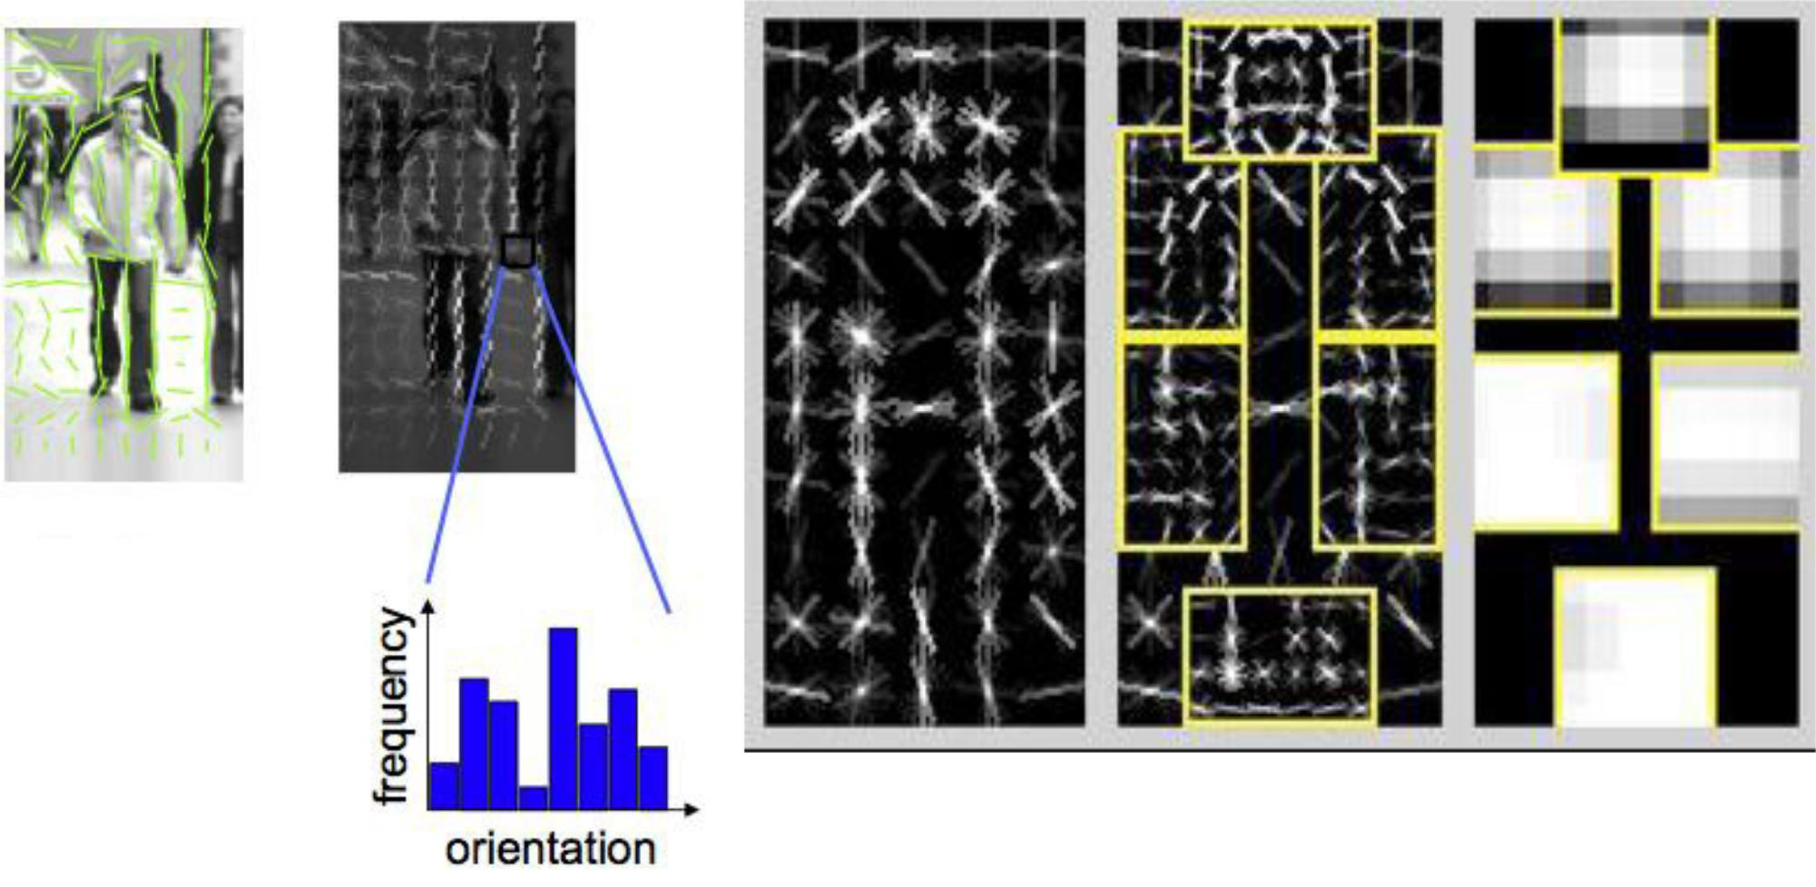

Histogram of Gradients (HoG) Deformable Part Model

Dalal & Triggs, 2005 Felzenswalb, McAllester, Ramanan,

2009



Fei-Fei Li & Andrej Karpathy & Justin Johnson

|  |  |
| --- | --- |
| Lecture 1 - 20 | 4-Jan-16 |

**PASCAL Visual Object Challenge**

**(20 object categories)**

[Everingham et al. 2006-2012]

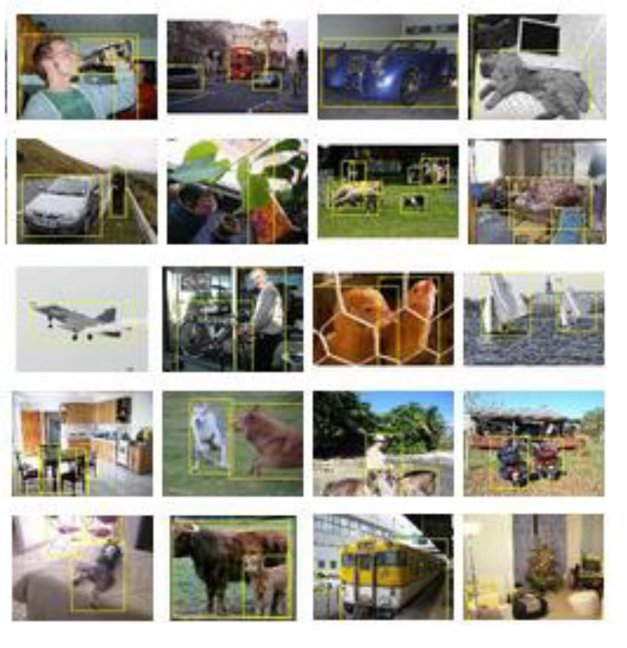

|  |  |  |
| --- | --- | --- |
|  | 1 |  |
| Precision | 0.9 |  |
| 0.8 |  |
|  |  |
| Average | 0.7 |  |
| 0.6 |  |
|  |  |
|  | 0.5 |  |
|  | 0.4 |  |

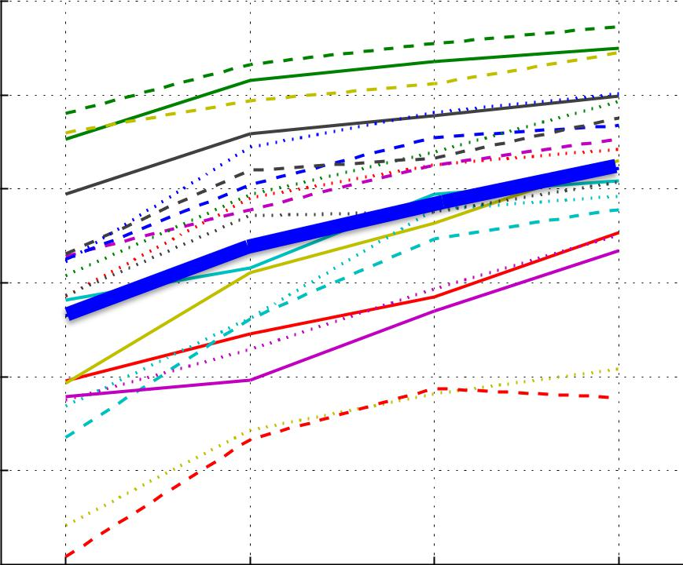

2009 2010 2011 2012

Challenge Year



 all



aeroplane



bicycle



bird



boat



bottle



bus



car



cat



chair



cow



diningtable



dog



horse



motorbike



person



pottedplant



sheep



sofa



train



tvmonitor



Fei-Fei Li & Andrej Karpathy & Justin Johnson

|  |  |
| --- | --- |
| Lecture 1 - 21 | 4-Jan-16 |



**www.image-net.org**

**22K** categories and **14M** images

|  |  |  |  |  |  |  |  |  |  |  |
| --- | --- | --- | --- | --- | --- | --- | --- | --- | --- | --- |
| **•** Animals | | **•** | Plants | | **•** | Structures | | **•** | Person | |
| **•** | Bird |  | **•** | Tree | **•** | Artifact | | **•** | Scenes | |
| **•** | Fish |  | **•** | Flower |  | **•** | Tools |  | **•** | Indoor |
| **•** | Mammal | **•** | Food |  |  | **•** | Appliances |  | **•** | Geological Formations |
| **•** | Invertebrate | **•** | Materials | |  | **•** | Structures | **•** | Sport Activities | |

Fei-Fei Li & Andrej Karpathy & Justin Johnson

Deng, Dong, Socher, Li, Li, & Fei-Fei, 2009

|  |  |
| --- | --- |
| Lecture 1 - 22 | 4-Jan-16 |



Steel drum

The Image Classification Challenge:

1,000 object classes

1,431,167 images

|  |  |  |  |  |  |  |  |
| --- | --- | --- | --- | --- | --- | --- | --- |
|  | **Output:** | |  |  | **Output:** |  |  |
|  | Scale | |  |  | Scale |  |  |
|  |  | ✗ |  |
|  | ✔ |  |
|  | T-shirt | |  | T-shirt |  |
|  | Steel drum |  |  | Giant panda |  |
|  | Drumstick | |  |  | Drumstick |  |  |
|  |  |  |  |
|  | Mud turtle | |  |  | Mud turtle |  |  |
|  |  |  |  |  |  |  |  |

Russakovsky et al. arXiv, 2014

Fei-Fei Li & Andrej Karpathy & Justin Johnson

|  |  |
| --- | --- |
| Lecture 1 - 23 | 4-Jan-16 |

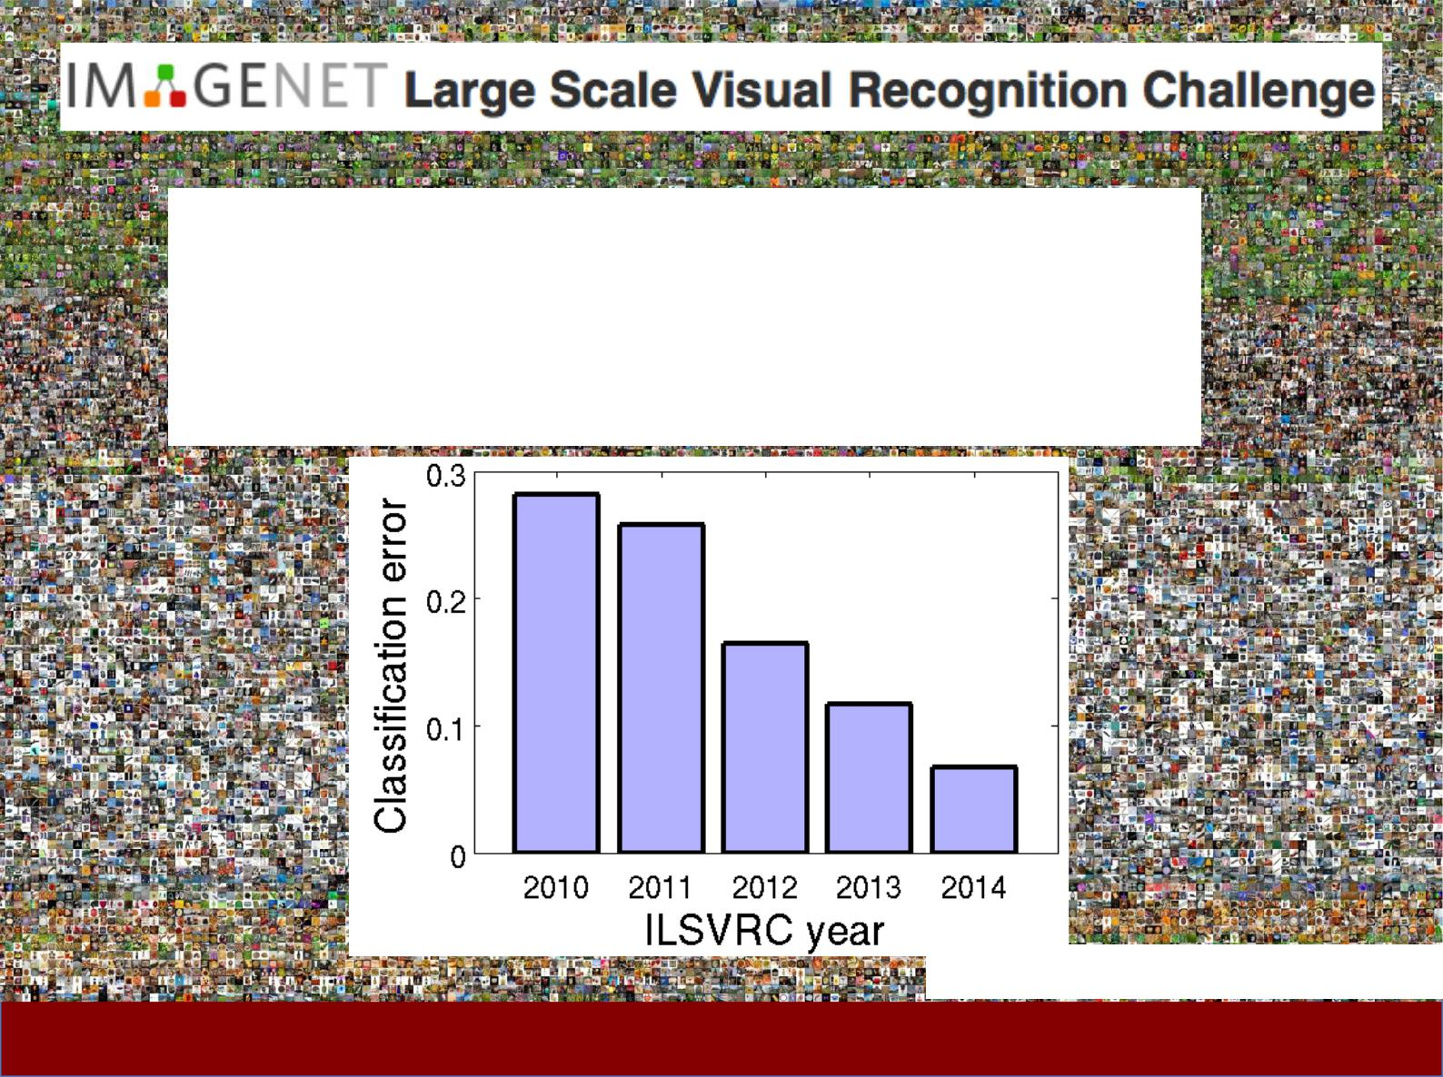

Steel drum

The Image Classification Challenge:

1,000 object classes

1,431,167 images

**0.28**

**0.26**

**0.16**

**0.12**

**0.07**

Russakovsky et al. arXiv, 2014

Fei-Fei Li & Andrej Karpathy & Justin Johnson

|  |  |
| --- | --- |
| Lecture 1 - 24 | 4-Jan-16 |

Today**’**s agenda

* A brief history of computer vision
* CS231n overview



Fei-Fei Li & Andrej Karpathy & Justin Johnson

|  |  |
| --- | --- |
| Lecture 1 - 25 | 4-Jan-16 |

CS231n focuses on one of the most important

problems of visual recognition **–**

*image classification*



Fei-Fei Li & Andrej Karpathy & Justin Johnson

|  |  |
| --- | --- |
| Lecture 1 - 26 | 4-Jan-16 |

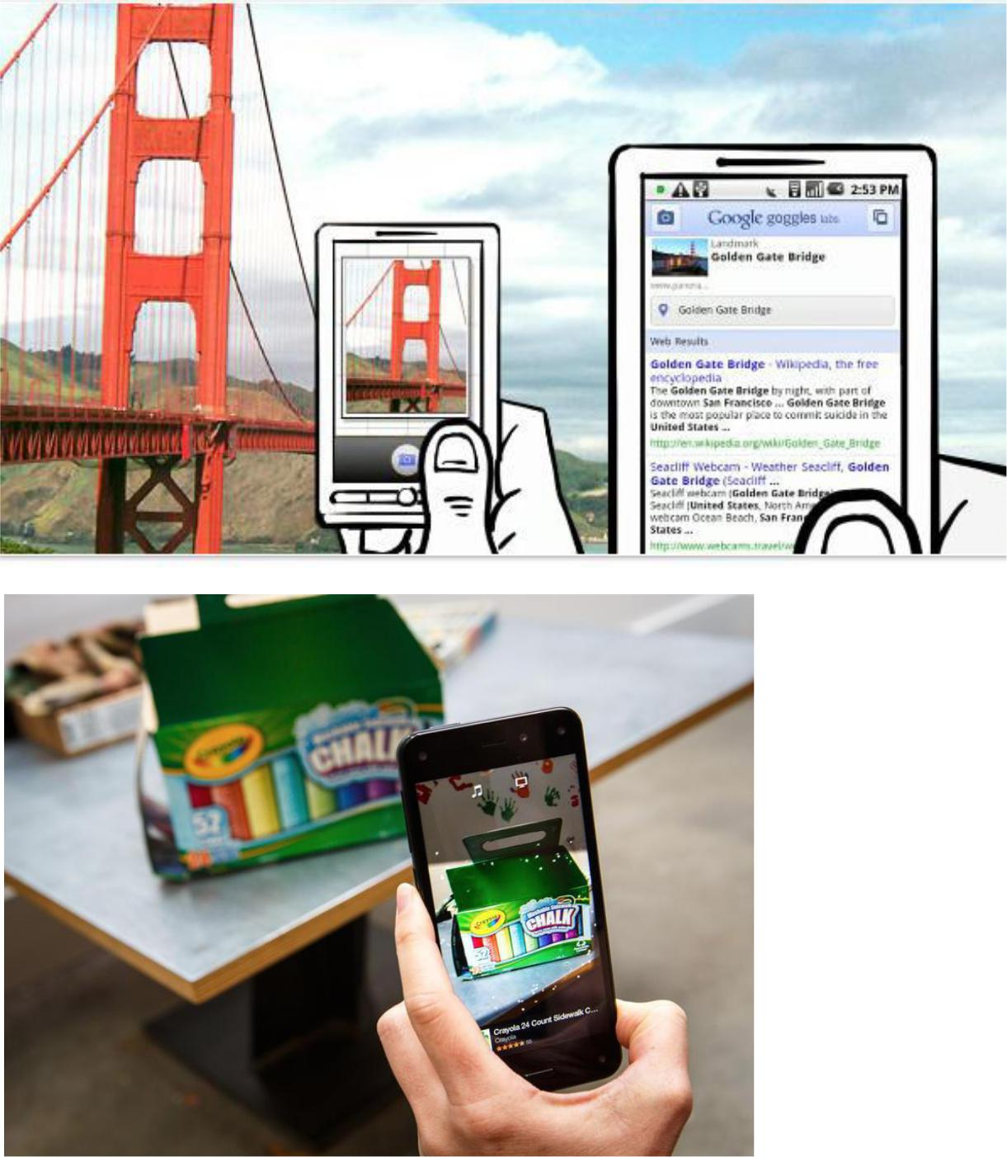

Fei-Fei Li & Andrej Karpathy & Justin Johnson

|  |  |
| --- | --- |
| Lecture 1 - 27 | 4-Jan-16 |

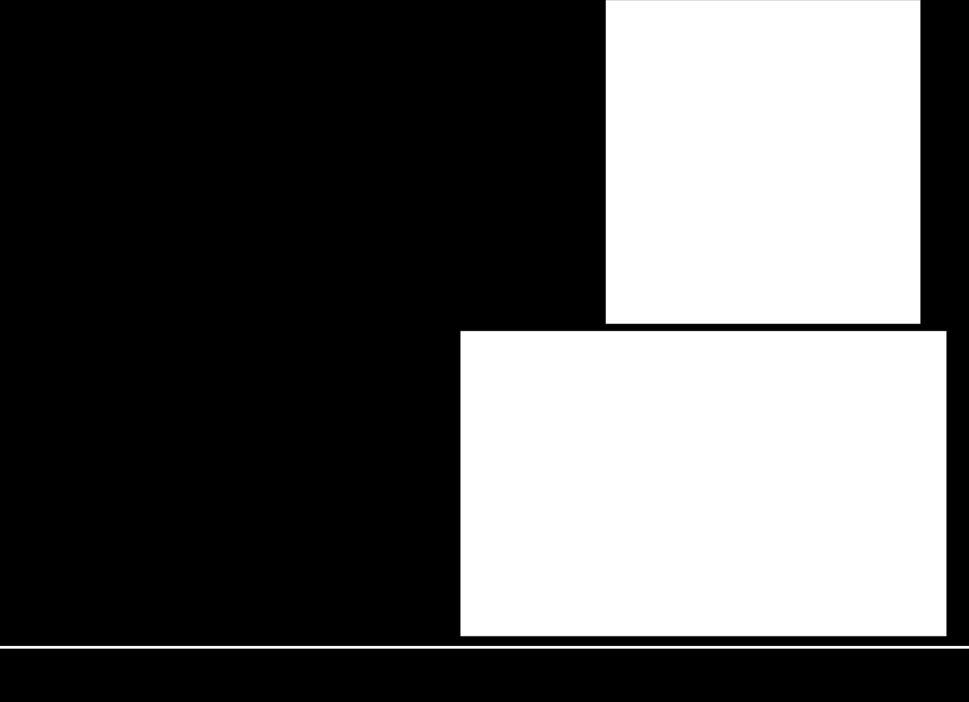

There is a number of visual recognition problems

that are related to image classification, such as *object detection, image captioning*



Fei-Fei Li & Andrej Karpathy & Justin Johnson

|  |  |
| --- | --- |
| Lecture 1 - 28 | 4-Jan-16 |

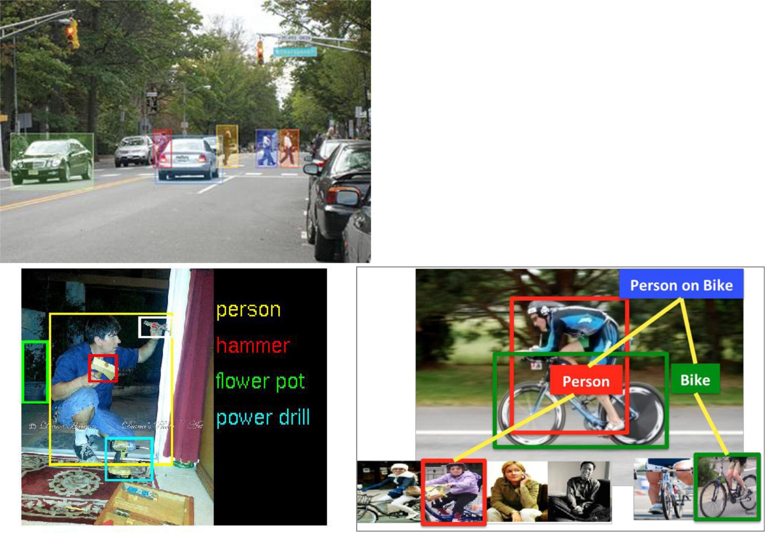

* Object detection
* Action classification
* Image captioning
* **…**



Fei-Fei Li & Andrej Karpathy & Justin Johnson

|  |  |
| --- | --- |
| Lecture 1 - 29 | 4-Jan-16 |

*Convolutional Neural Network (CNN)* hasbecome an important tool for object recognition



Fei-Fei Li & Andrej Karpathy & Justin Johnson

|  |  |
| --- | --- |
| Lecture 1 - 30 | 4-Jan-16 |

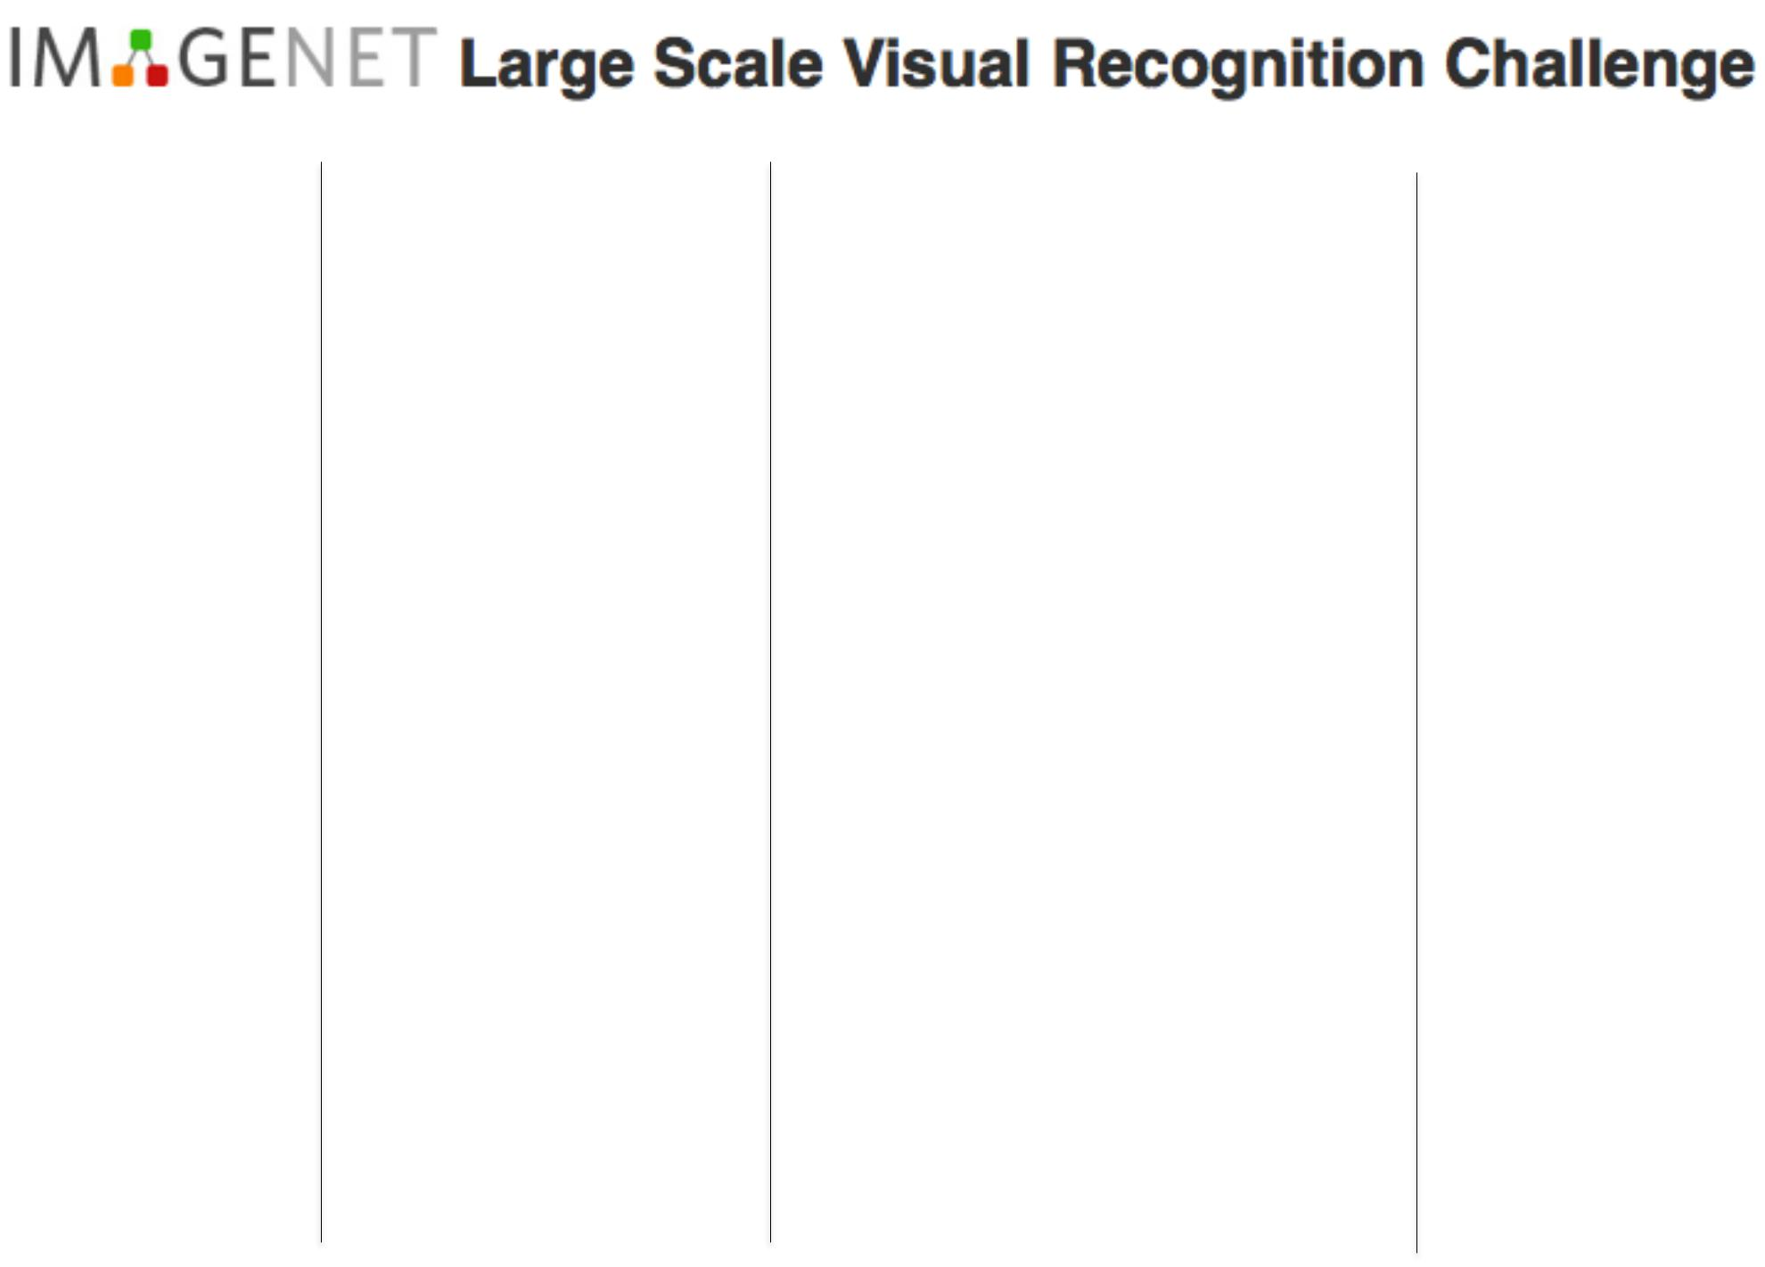

|  |  |  |  |  |  |  |  |  |  |  |
| --- | --- | --- | --- | --- | --- | --- | --- | --- | --- | --- |
|  | **Year 2010** | |  | **Year 2012** | |  | **Year 2014** | | **Year 2015** | |
|  |  |  |  |  |  |  |  |  |  |  |
| NEC-UIUC | | | SuperVision | | | GoogLeNet VGG | | | MSRA | |

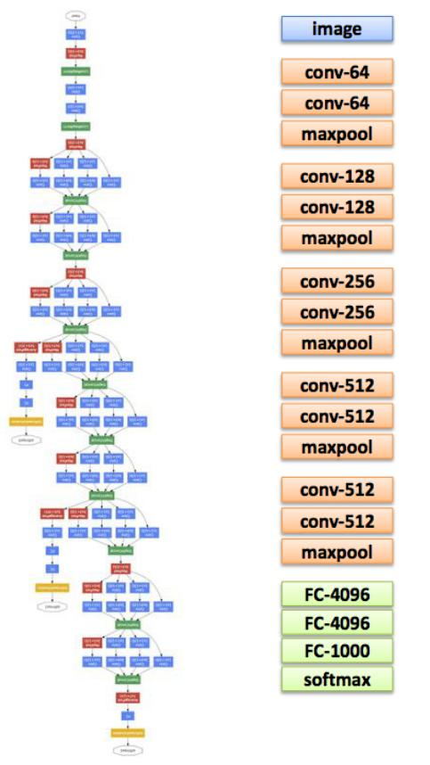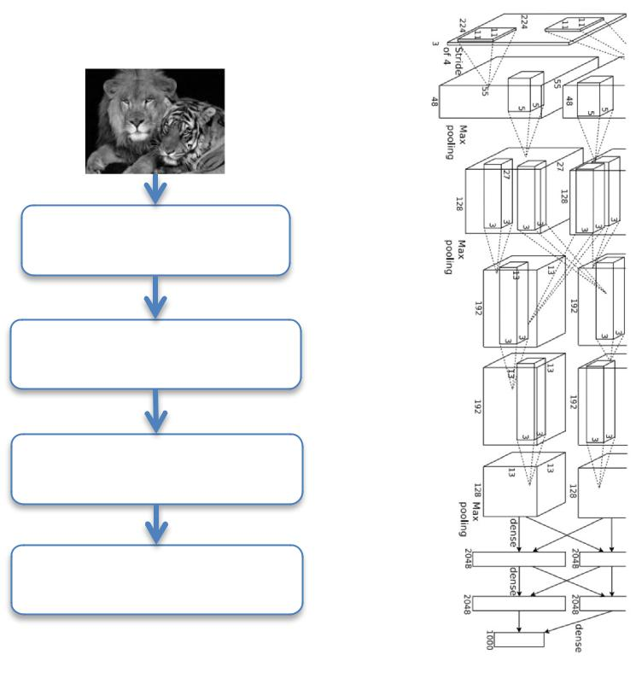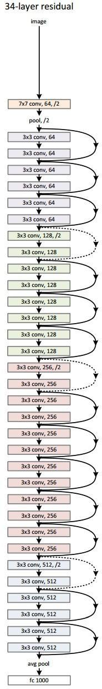

Dense grid descriptor:

HOG, LBP

Coding: local coordinate,

super-vector

Pooling, SPM

Linear SVM

Convolution

Pooling

Softmax

Other

|  |  |  |
| --- | --- | --- |
| [Lin CVPR 2011] | [Krizhevsky NIPS 2012] | [Szegedy arxiv 2014] [Simonyan arxiv 2014] |



Fei-Fei Li & Andrej Karpathy & Justin Johnson

|  |  |
| --- | --- |
| Lecture 1 - 31 | 4-Jan-16 |

*Convolutional Neural Network (CNN)*

is not invented overnight



Fei-Fei Li & Andrej Karpathy & Justin Johnson

|  |  |
| --- | --- |
| Lecture 1 - 32 | 4-Jan-16 |

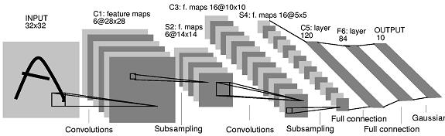

1998

LeCun et al.

|  |  |
| --- | --- |
| # of transistors | # of pixels used in training |
| 106 | 107 |
|  |  |

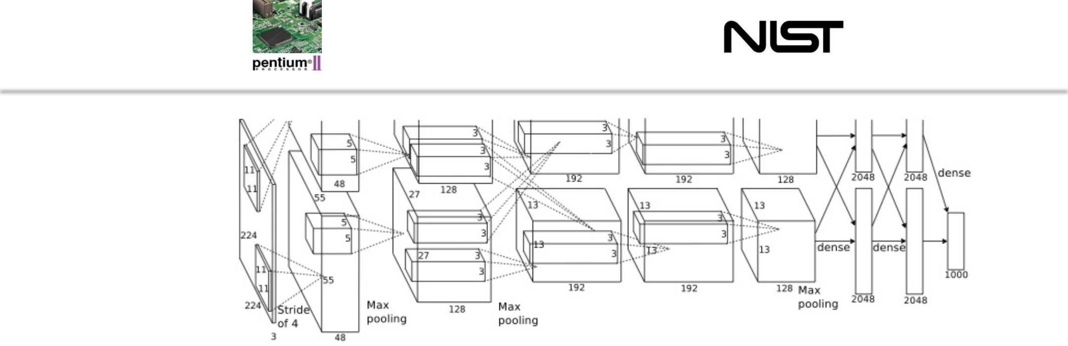

2012

Krizhevsky et al.

# of transistors GPUs # of pixels used in training

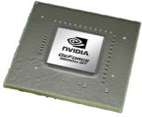

109 1014 



Fei-Fei Li & Andrej Karpathy & Justin Johnson

|  |  |
| --- | --- |
| Lecture 1 - 33 | 4-Jan-16 |

The quest for visual intelligence

goes far beyond object recognition**…**



Fei-Fei Li & Andrej Karpathy & Justin Johnson

|  |  |
| --- | --- |
| Lecture 1 - 34 | 4-Jan-16 |

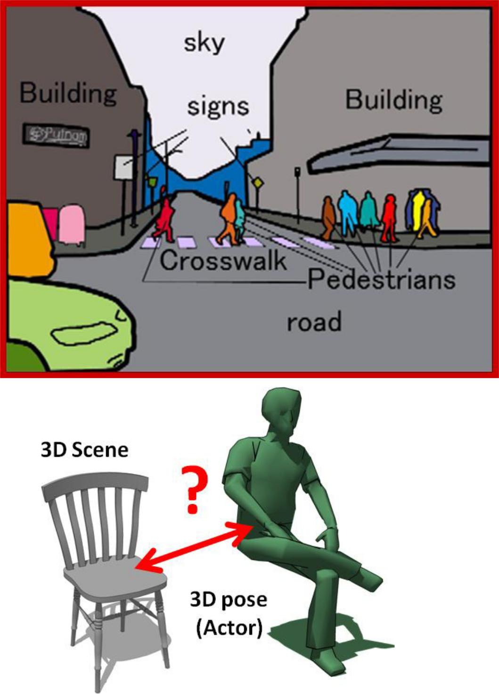

Fei-Fei Li & Andrej Karpathy & Justin Johnson

|  |  |
| --- | --- |
| Lecture 1 - 35 | 4-Jan-16 |

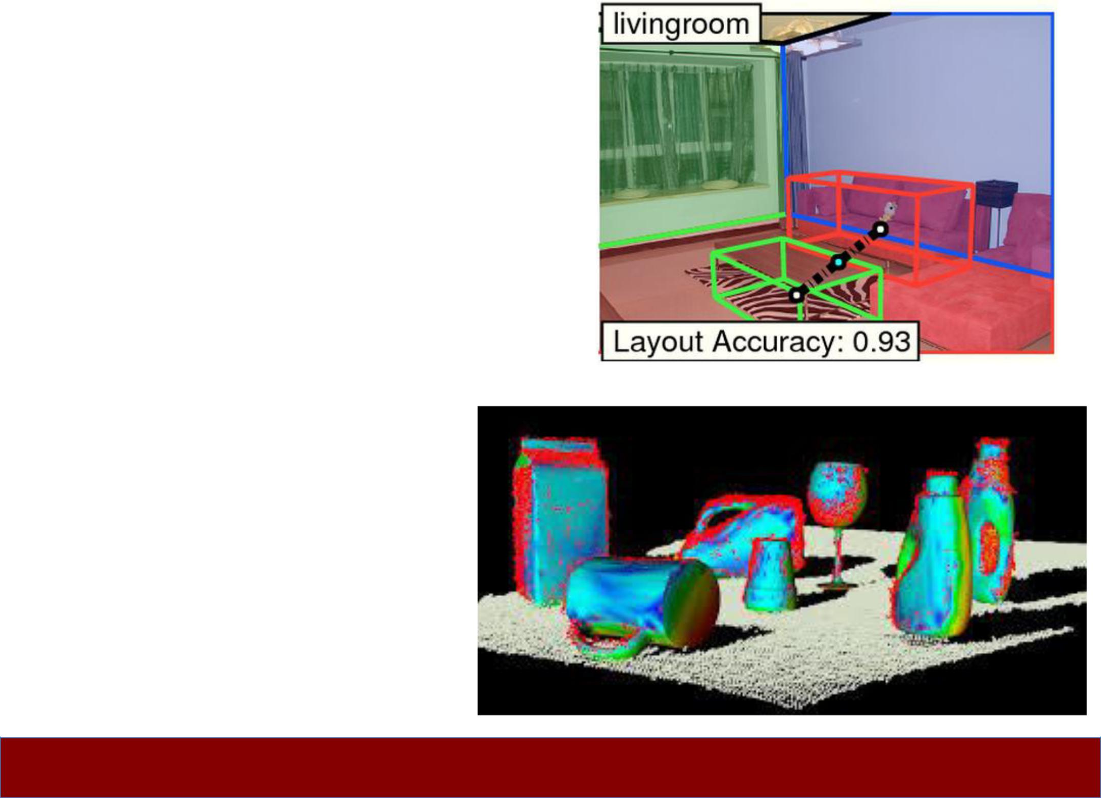

Fei-Fei Li & Andrej Karpathy & Justin Johnson

|  |  |
| --- | --- |
| Lecture 1 - 36 | 4-Jan-16 |

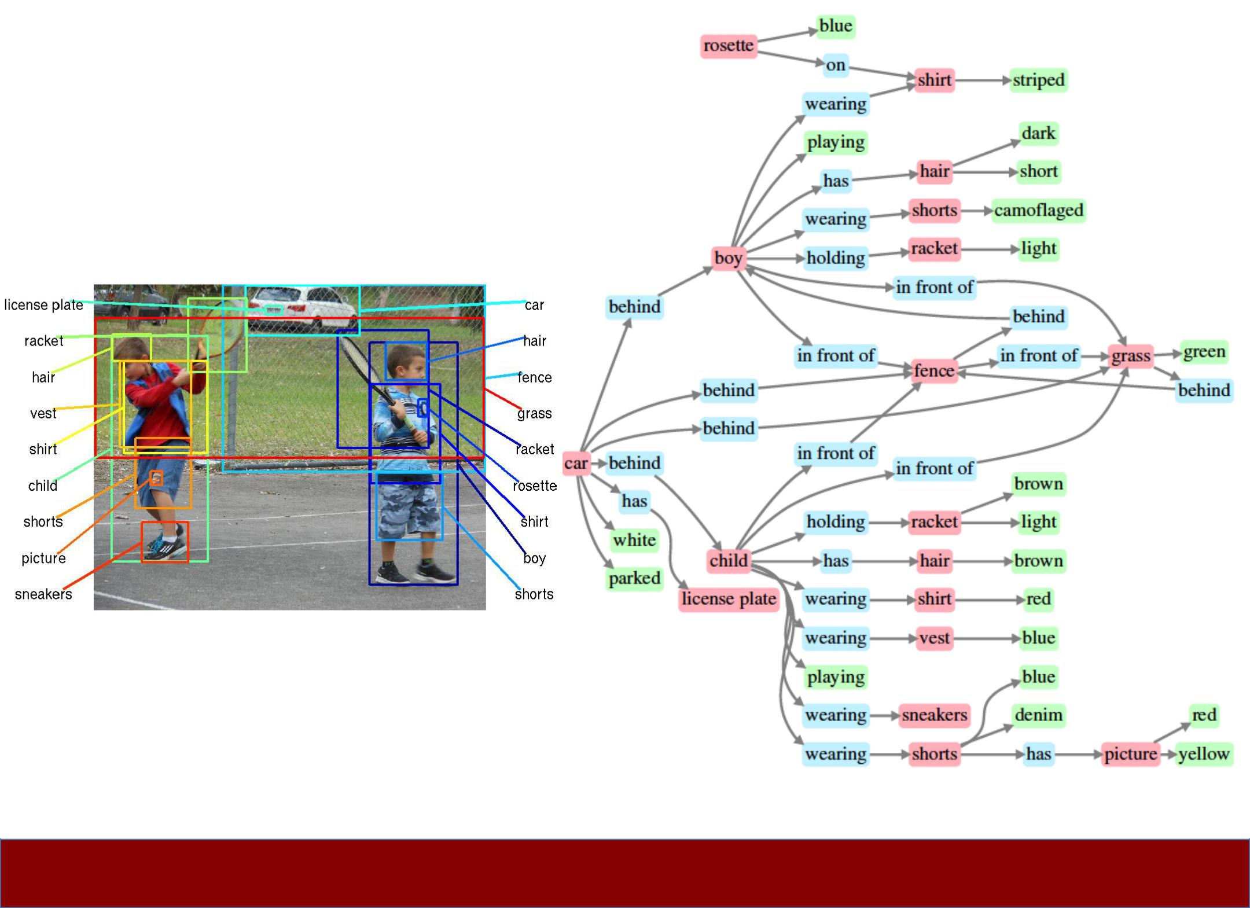

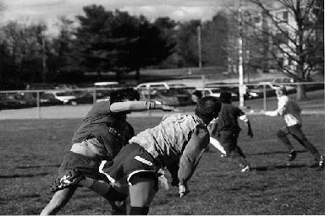

**PT = 500ms**

Some kind of game or fight. Two groups of two men? The foregound pair looked like one was getting a fist in the face. Outdoors seemed like because i have an impression of grass and maybe lines on the grass? That would be why I think perhaps a game, rough game though, more like rugby than football because they pairs weren't in pads and helmets, though I did get the impression of similar clothing. maybe some trees? in the background. (Subject: SM)

Fei-Fei, Iyer, Koch, Perona, *JoV,* 2007



Fei-Fei Li & Andrej Karpathy & Justin Johnson

|  |  |
| --- | --- |
| Lecture 1 - 37 | 4-Jan-16 |

Fei-Fei Li & Andrej Karpathy & Justin Johnson

|  |  |
| --- | --- |
| Lecture 1 - 38 | 4-Jan-16 |



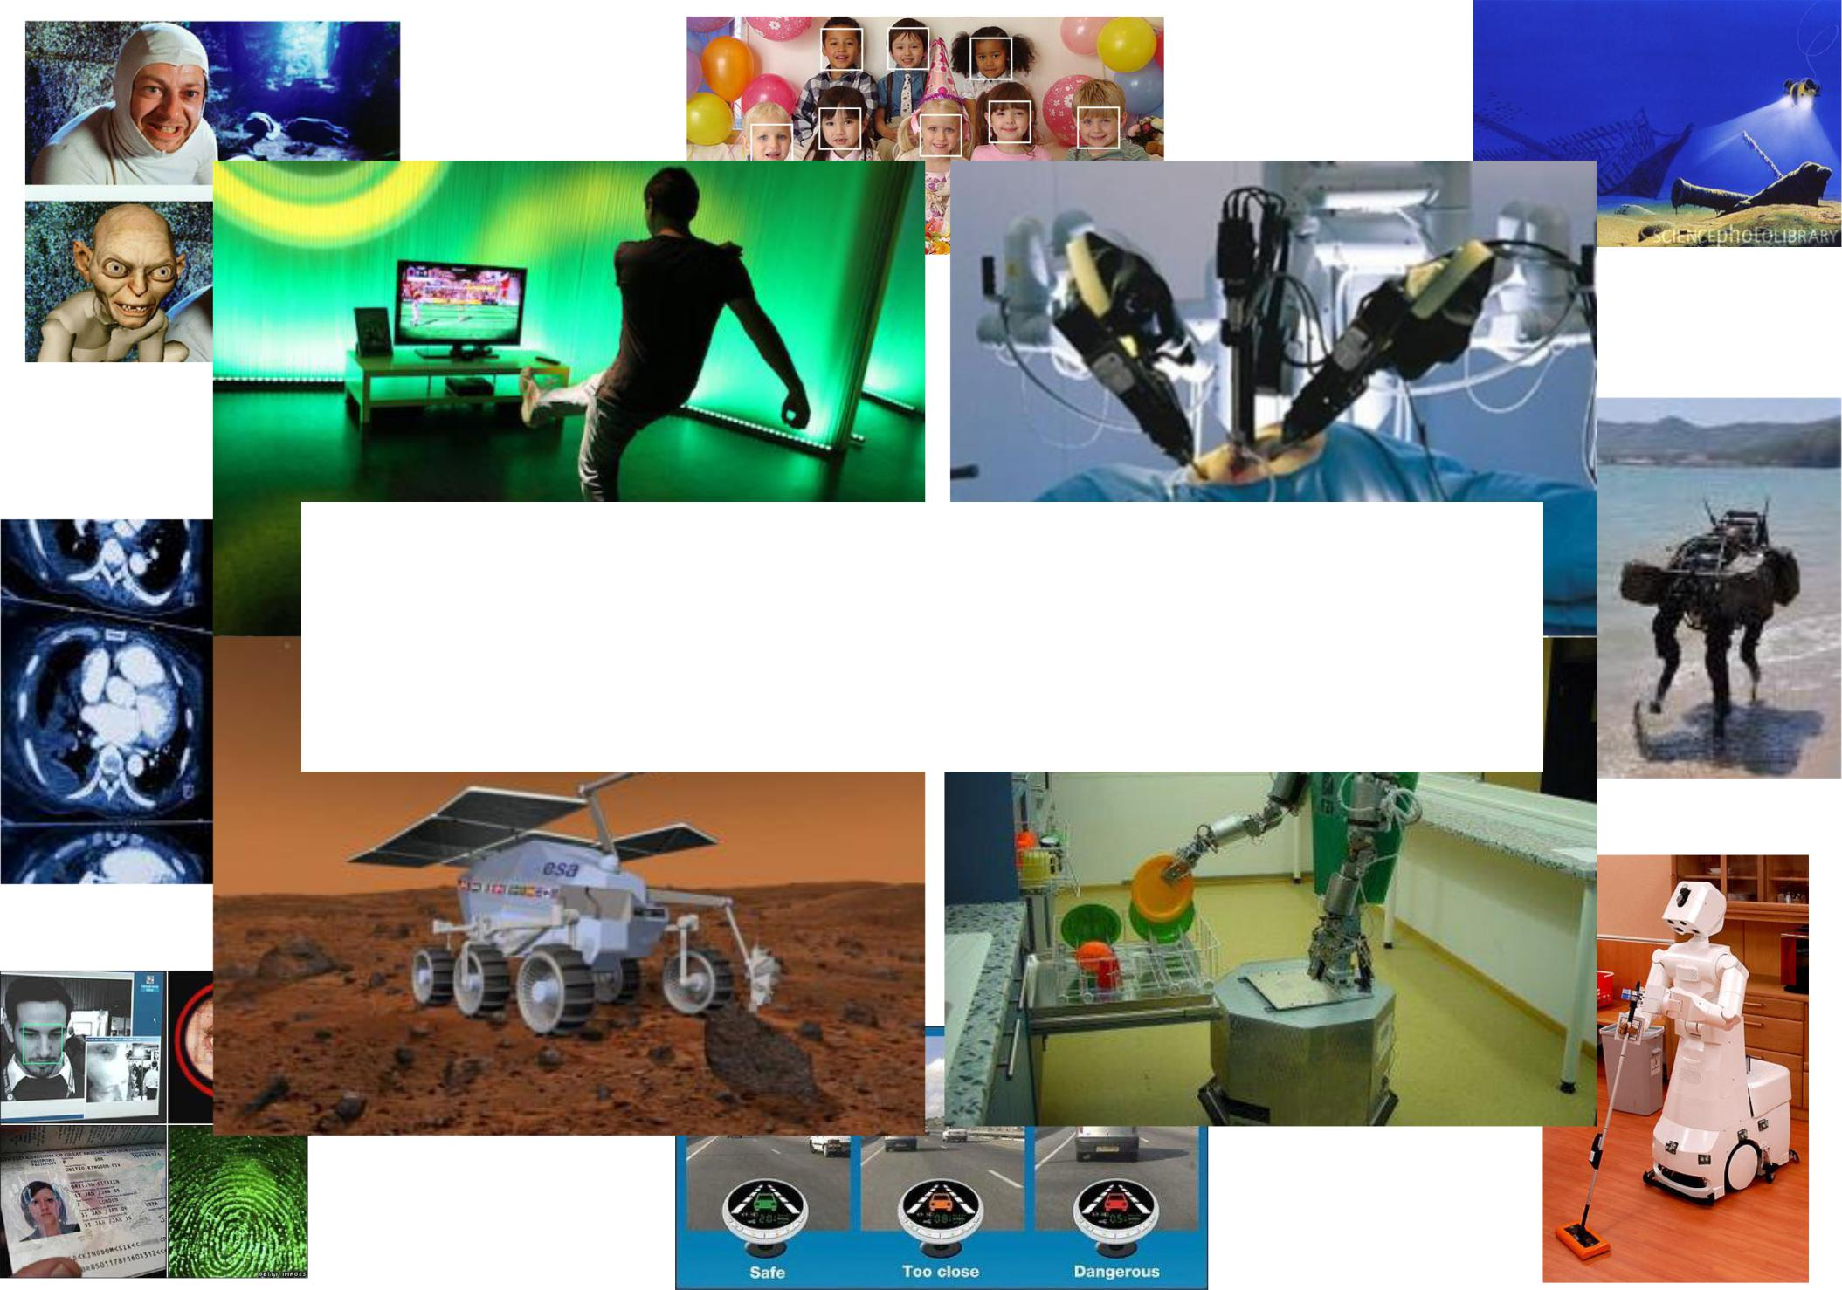

**Computer Vision Technology Can Better Our Lives**



Fei-Fei Li & Andrej Karpathy & Justin Johnson

|  |  |
| --- | --- |
| Lecture 1 - 39 | 4-Jan-16 |

Who we are

* Instructors
* Teaching Assistants
* Keeping in touch:

**– cs231n-winter1516-staff@lists.stanford.edu**

**– Piazza**



Fei- Fei Li & Andrej Karpathy & Justin Johnson

|  |  |
| --- | --- |
| Lecture 1 - 40 | 4-Jan-16 |

Our philosophy

* Thorough and Detailed.

**–** Understand how to write from scratch, debug and trainconvolutional neural networks.

* Practical.

**–** Focus on practical techniques for training these networksat scale, and on GPUs (e.g. will touch on distributed optimization, differences between CPU vs. GPU, etc.) Also look at state of the art software tools such as Caffe, maybe also Torch and TensorFlow

* State of the art.

**–** Most materials are new from research world in the past 1-3years. Very exciting stuff!

* Fun.

**–** Some fun topics such as Image Captioning (using RNN)

**–** Also DeepDream, NeuralStyle, etc.



Fei-Fei Li & Andrej Karpathy & Justin Johnson

|  |  |
| --- | --- |
| Lecture 1 - 41 | 4-Jan-16 |

Our philosophy (cont**’**d)

* Fun.

**–** Some fun topics such as Image Captioning (using RNN)

**–** Also DeepDream, NeuralStyle, etc.

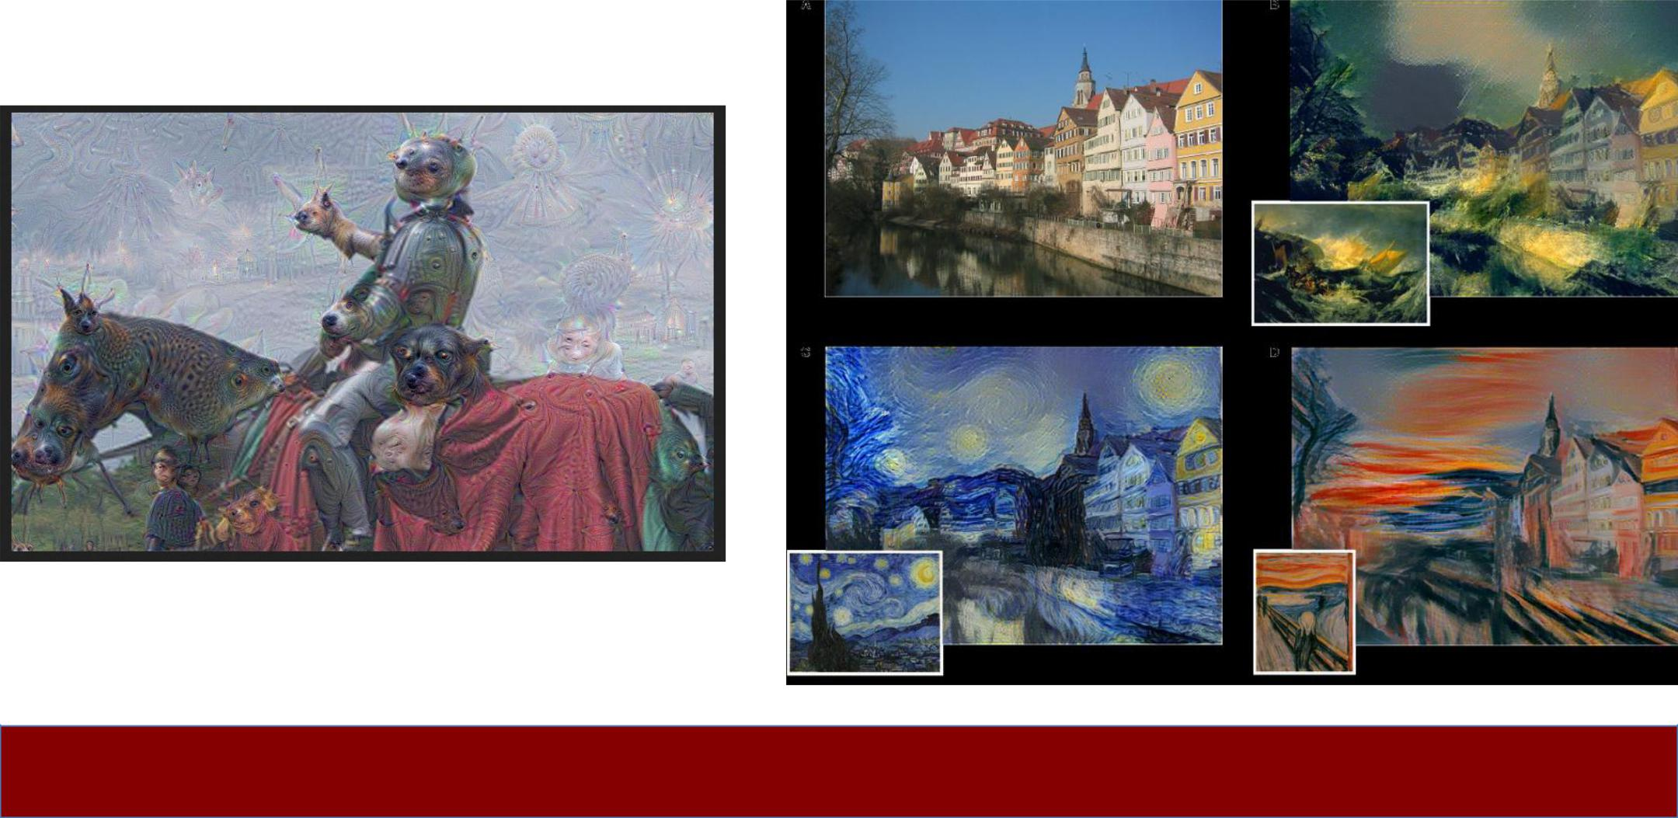

Fei-Fei Li & Andrej Karpathy & Justin Johnson

|  |  |
| --- | --- |
| Lecture 1 - 42 | 4-Jan-16 |

Grading policy

* 3 Problem Sets: 15% x 3 = 45%
* Midterm Exam: 15%
* Final Course Project: 40%

**–** Milestone: 5%

**–** Final write-up: 35%

**–** Bonus points for exceptional poster presentation

* Late policy

**–** 7 free late days **–** use them in your ways

**–** Afterwards, 25% off per day late

**–** Not accepted after 3 late days per PS

**–** Does not apply to Final Course Project

* Collaboration policy

**–** Read the student code book, understand what is **‘**collaboration**’** and what is **‘**academic infraction**’**



Fei-Fei Li & Andrej Karpathy & Justin Johnson

|  |  |
| --- | --- |
| Lecture 1 - 43 | 4-Jan-16 |

Pre-requisite

* Proficiency in Python, some high-level familiarity with C/C++

**–** All class assignments will be in Python (and usenumpy), but some of the deep learning libraries we

may look at later in the class are written in C++.

**–** A Python tutorial available on course website

* College Calculus, Linear Algebra
* Equivalent knowledge of CS229 (Machine Learning)

**–** We will be formulating cost functions, takingderivatives and performing optimization with gradient descent.



Fei- Fei Li & Andrej Karpathy & Justin Johnson

|  |  |
| --- | --- |
| Lecture 1 - 44 | 4-Jan-16 |

Syllabus

* Go to website**…**

http://vision.stanford.edu/teaching/cs231n/index.html



Fei-Fei Li & Andrej Karpathy & Justin Johnson

|  |  |
| --- | --- |
| Lecture 1 - 45 | 4-Jan-16 |

References

* Hubel, David H., and Torsten N. Wiesel. "Receptive fields, binocular interaction and functional architecture in the cat's visual cortex." The Journal of physiology 160.1 (1962): 106. [PDF]
* Roberts, Lawrence Gilman. "Machine Perception of Three-dimensional Solids." Diss. Massachusetts Institute of Technology, 1963. [PDF]
* Marr, David. "Vision.**”** The MIT Press, 1982. [PDF]
* Brooks, Rodney A., and Creiner, Russell and Binford, Thomas O. "The ACRONYM model-based vision system. " In Proceedings of the 6th International Joint Conference on Artificial Intelligence (1979): 105-113. [PDF]
* Fischler, Martin A., and Robert A. Elschlager. "The representation and matching of pictorial structures." IEEE Transactions on Computers 22.1 (1973): 67-92. [PDF]
* Lowe, David G., "Three-dimensional object recognition from single two-dimensional images," Artificial Intelligence, 31, 3 (1987), pp. 355-395. [PDF]
* Shi, Jianbo, and Jitendra Malik. "Normalized cuts and image segmentation." Pattern Analysis and Machine Intelligence, IEEE Transactions on 22.8 (2000): 888-905. [PDF]
* Viola, Paul, and Michael Jones. "Rapid object detection using a boosted cascade of simple features." Computer Vision and Pattern Recognition, 2001. CVPR 2001. Proceedings of the 2001 IEEE Computer Society Conference on. Vol. 1. IEEE, 2001. [PDF]
* Lowe, David G. "Distinctive image features from scale-invariant keypoints." International Journal of Computer Vision 60.2 (2004): 91-110. [PDF]
* Lazebnik, Svetlana, Cordelia Schmid, and Jean Ponce. "Beyond bags of features: Spatial pyramid matching for recognizing natural scene categories." Computer Vision and Pattern Recognition, 2006 IEEE Computer Society Conference on. Vol. 2. IEEE, 2006. [PDF]



Fei-Fei Li & Andrej Karpathy & Justin Johnson

|  |  |
| --- | --- |
| Lecture 1 - 46 | 4-Jan-16 |

* Dalal, Navneet, and Bill Triggs. "Histograms of oriented gradients for human detection." Computer Vision and Pattern Recognition, 2005. CVPR 2005. IEEE Computer Society Conference on. Vol. 1. IEEE, 2005. [PDF]
* Felzenszwalb, Pedro, David McAllester, and Deva Ramanan. "A discriminatively trained, multiscale, deformable part model." Computer Vision and Pattern Recognition, 2008. CVPR 2008. IEEE Conference on. IEEE, 2008 [PDF]
* Everingham, Mark, et al. "The pascal visual object classes (VOC) challenge." International Journal of Computer Vision 88.2 (2010): 303-338. [PDF]
* Deng, Jia, et al. "Imagenet: A large-scale hierarchical image database." Computer Vision and Pattern Recognition, 2009. CVPR 2009. IEEE Conference on. IEEE, 2009. [PDF]
* Russakovsky, Olga, et al. "Imagenet Large Scale Visual Recognition Challenge." arXiv:1409.0575. [PDF]
* Lin, Yuanqing, et al. "Large-scale image classification: fast feature extraction and SVM training." Computer Vision and Pattern Recognition (CVPR), 2011 IEEE Conference on. IEEE, 2011. [PDF]
* Krizhevsky, Alex, Ilya Sutskever, and Geoffrey E. Hinton. "Imagenet classification with deep convolutional neural networks." Advances in neural information processing systems. 2012. [PDF]
* Szegedy, Christian, et al. "Going deeper with convolutions." arXiv preprint arXiv:1409.4842 (2014). [PDF]
* Simonyan, Karen, and Andrew Zisserman. "Very deep convolutional networks for large-scale image recognition." arXiv preprint arXiv:1409.1556 (2014). [PDF]
* He, Kaiming, et al. "Spatial Pyramid Pooling in Deep Convolutional Networks for Visual Recognition." arXiv preprint arXiv:1406.4729 (2014). [PDF]
* LeCun, Yann, et al. "Gradient-based learning applied to document recognition." Proceedings of the IEEE 86.11 (1998): 2278-2324. [PDF]
* Fei-Fei, Li, et al. "What do we perceive in a glance of a real-world scene?." Journal of vision 7.1 (2007): 10. [PDF]



Fei-Fei Li & Andrej Karpathy & Justin Johnson

|  |  |
| --- | --- |
| Lecture 1 - 47 | 4-Jan-16 |